HURDEBOURCQ Paul
TP5
R1-05 : BDD

Travaux effectués : | A retenir :
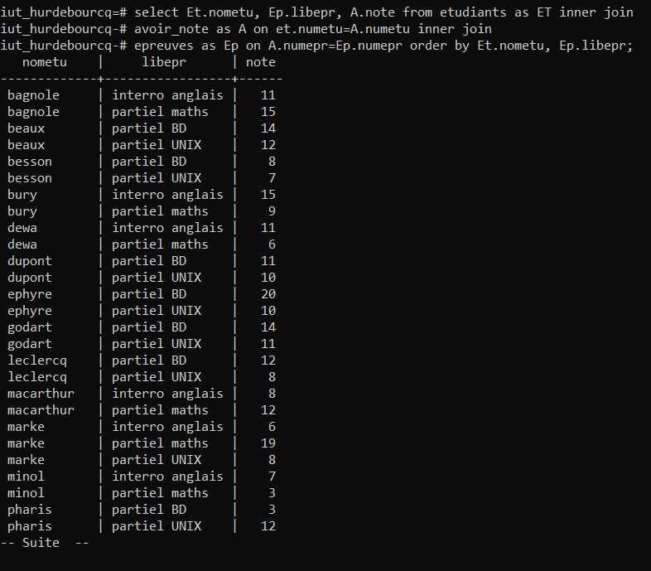 | select Et.nometu, Ep.libepr, A.note from etudiants as ET inner join avoir_note as A on et.numetu=A.numetu inner join epreuves as Ep on A.numepr=Ep.numepr order by Et.nometu, Ep.libepr;
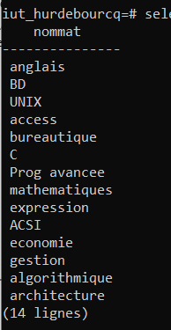 | select nommat from matieres inner join modules on matieres.nummod = modules.nummod;
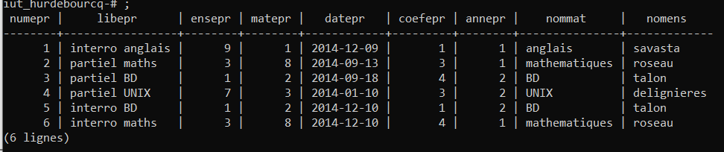 | select numepr,libepr,ensepr,matepr,datepr,coefepr,annepr,nommat,nomens from  epreuves inner join matieres on epreuves.matepr = matieres.nummat inner join enseignants on epreuves.ensepr = enseignants.numens;
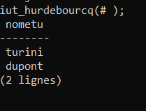 | select nometu from etudiants inner join avoir_note on etudiants.numetu = avoir_note.numetu inner join epreuves on avoir_note.numepr=epreuves.numepr where libepr like 'partiel BD' and note in (select note from avoir_note inner join etudiants on avoir_note.numetu = etudiants.numetu where nometu like 'dupont' and prenometu like 'luc');
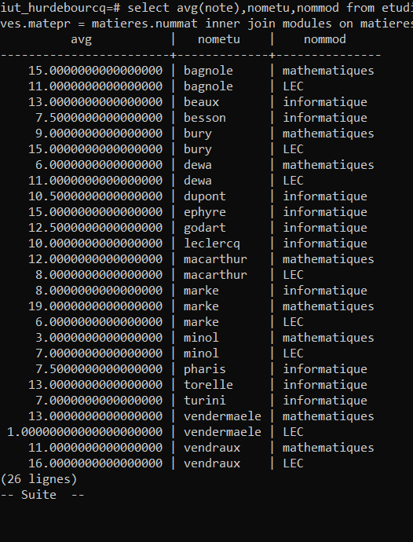 | select avg(note),nometu,nommod from etudiants inner join avoir_note on etudiants.numetu=avoir_note.numetu inner join epreuves on avoir_note.numepr = epreuves.numepr inner join matieres on epreuves.matepr = matieres.nummat inner join modules on matieres.nummod=modules.nummod group by modules.nummod,etudiants.nometu order by etudiants.nometu asc;
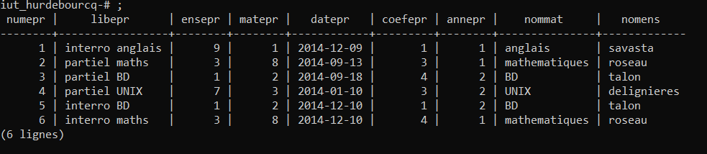 | select numepr,libepr,ensepr,matepr,datepr,coefepr,annepr,nommat,nomens from  epreuves inner join matieres on epreuves.matepr = matieres.nummat inner join enseignants on epreuves.ensepr = enseignants.numens  ;
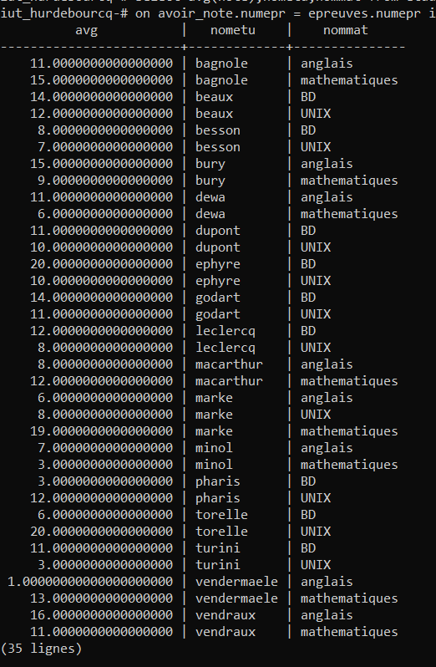 | select avg(note),nometu,nommat from etudiants inner join avoir_note on etudiants.numetu=avoir_note.numetu inner join epreuves  on avoir_note.numepr = epreuves.numepr inner join matieres on epreuves.matepr = matieres.nummat group by matieres.nummat,etudiants.nometu order by etudiants.nometu asc;
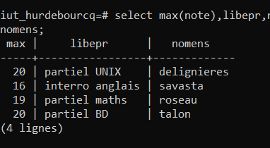 | select max(note),libepr,nomens from avoir_note inner join epreuves on avoir_note.numepr=epreuves.numepr inner join enseignants on epreuves.ensepr = enseignants.numens group by epreuves.libepr, nomens;
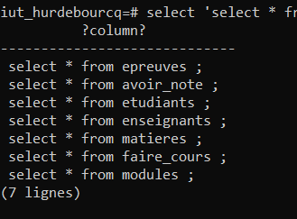 | select ‘select * from ‘||tablename||’ ; ‘from pg_tables where sechaname=’public’ ;
Page 1/ 28/10/21

